|  |
| --- |
| **ALU** |
|  |
| ***DE Lab Project Report*** |
| ***Submitted By*** |
| **Yash Raj - 18BCS6096**  **Megha Thakur - 18BCS6125**  **Karishma Kansal - 18BCS6103** |
| ***Under the Guidance of*** |
| **Mr. Anshul Sharma**  **Mr. Divneet Singh Kapoor**  **Mr. Khushal Thakur** |
| **Assistant Professors, Academic Unit – 1** |
|  |
| **Academic Unit-1**  **Chandigarh University** |

**1. Problem Identification**

Design a 4 bit ALU with adder,subtractor,or,and,increment,decrement,comparator operations.

**2. Features**

ALU – Arthmetic Logic Unit

It performs two block operations: Arthematic and Logic.

It can perform operations on 2 operands.4-bit binary information is input through the switch in hardware and in proteus through logical toggles and output is shown at LED’s.

It performs seven operations addition, subtraction, Increment A, Decrement A, 4 Bit AND, 4 Bit OR, 4 Bit Comparator.

All these operations are performed using Logic gates, by connecting them in proper proportion.

**3. Design Flow**

**Block Diagram**

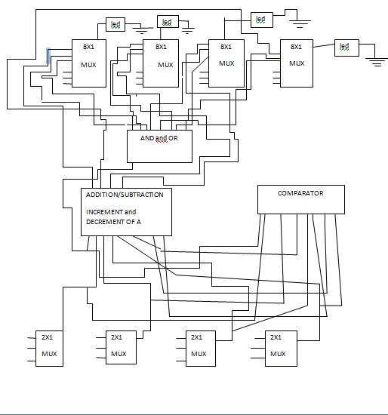

**Circuit Diagram**

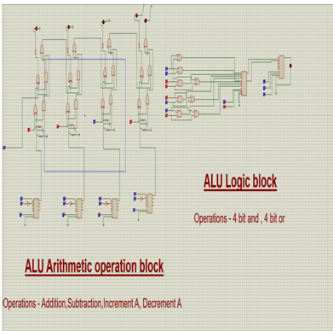

**Materials**

|  |  |  |
| --- | --- | --- |
| **Product** | **Specifications** | **Quantity** |
| IC | 7486 | 2 |
| IC | 7408 | 2 |
| IC | 7432 | 1 |
| IC Base |  | 5 |
| Slide Switch |  | 2 |
| LED | Red | 4 |
| LED | Blue | 1 |
| Resistor | 10k | 4 |
| Resistor | 100 Ω | 4 |
| Diode | IN4007 | 4 |
| Headers |  | 24 |
| PCB |  | 1 |
| Terminal Sleve |  | 1 Packet |
| Soldering Kit |  | 1 |

**4. Outcome**

**Steps of Circuit Completion**

1. Soldering of IC bases is done by soldering machine. IC bases are soldered on pcb board and wires are attached to each base.

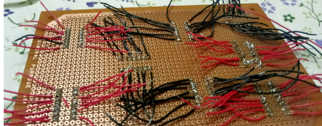

2. Top View

Led’s, slideswitches, resistors and diodes are fixed on pcb

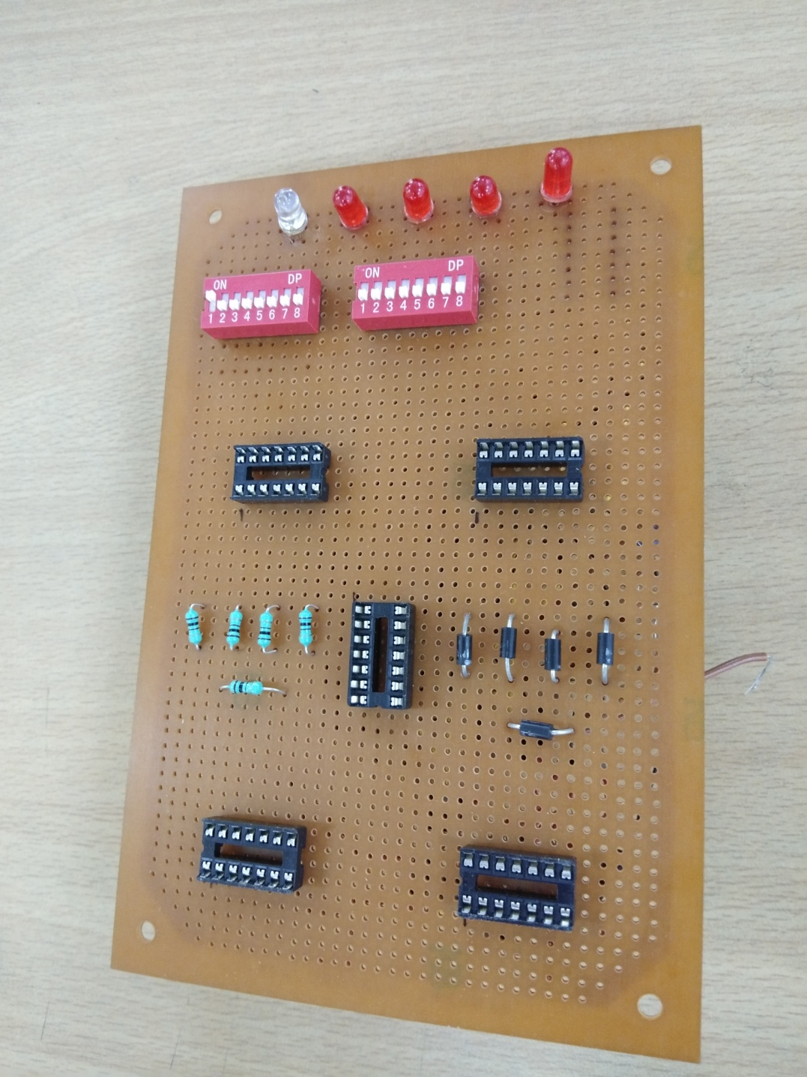

3.Connections are done by using the wires and all the connections are fully prevented by doing the taping.

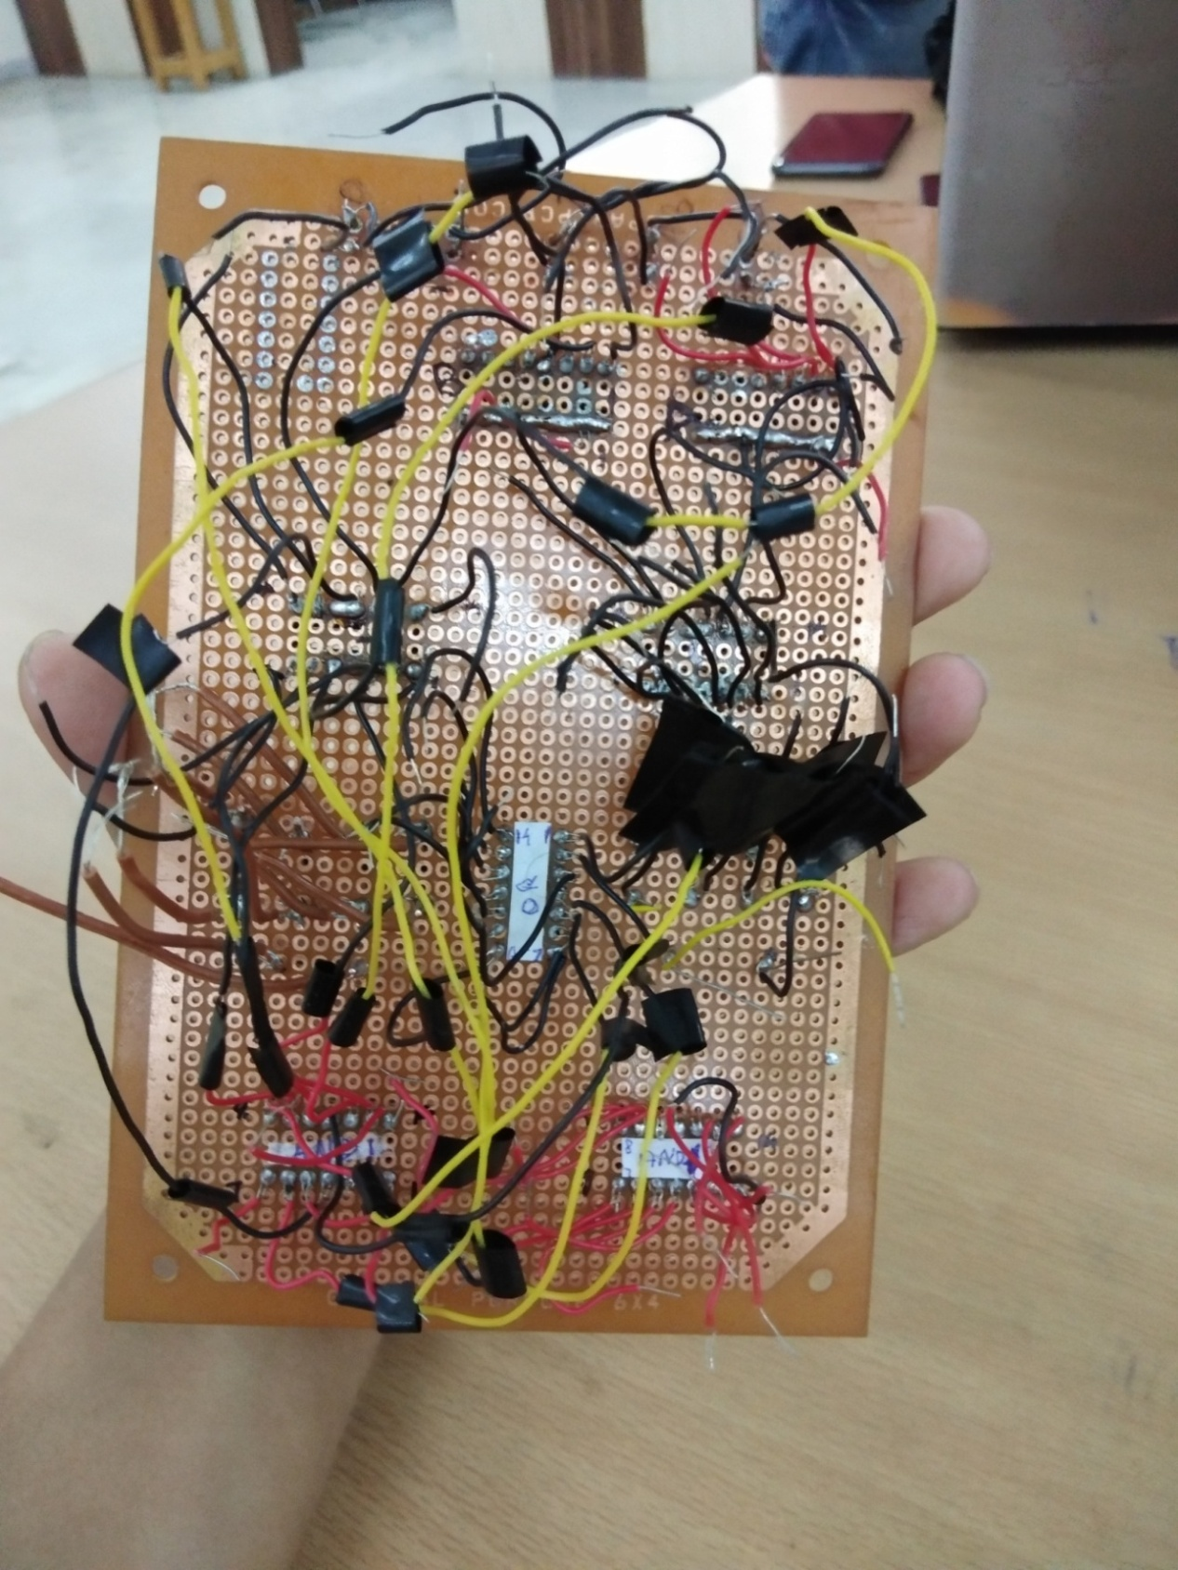

**5. Cost Analysis**

|  |  |  |
| --- | --- | --- |
| **S. No.** | **Component / Material** | **Price (in Rs.)** |
| 1 | IC - 7486 | 22 x 4 = 88 |
| 2. | IC - 7408 | 22 x 4 = 88 |
| 3. | IC - 7432 | 22 x 4 = 88 |
| 4. | IC base | 4 x 7 = 28 |
| 5. | Slide Switch | 25 x 4 = 100 |
| 6. | LED - Red | 1 x 6 = 6 |
| 7. | LED - Blue | 1 x 3 = 3 |
| 8. | Resistor - 10k | 2 x 6 = 12 |
| 9. | Resistor - 100 Ω | 2 x 6 = 12 |
| 10. | IN4007 Diode | 1 x 6 = 6 |
| 11. | Headers | 7 x 2 = 14 |
| 12. | PCB | 60 |
| 13. | Terminal Sleve | 30 |
| 14. | Soldering Kit | 550 |
| **Total** | | 1027 |